**Frontend Documentation for HubMarketocom**

**Project Overview**

**HubMarketocom is a web-based platform developed using Angular for the frontend. The application provides user authentication, including signup, login, and password reset functionalities.**

**Technologies Used**

* **Framework:** Angular
* **Styling:** CSS
* **Forms Handling:** Angular FormsModule
* **HTTP Requests:** HttpClient
* **Routing:** Angular Router

**Implemented Features**

**1. User Signup**

* Users can register by providing details like first name, last name, username, email, address, mobile number, gender, and password.
* Profile picture upload is enabled using Multer in the backend.

Form validation is implemented to ensure required fields are filled correctly.

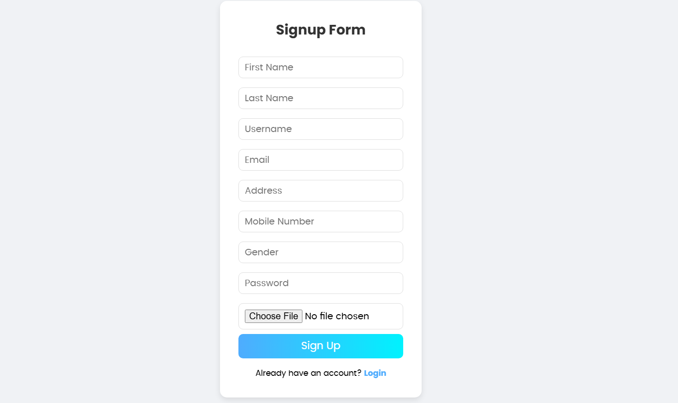

**2. User Login**

* Users can log in using their registered email and password.
* If credentials are incorrect, an error message is displayed.

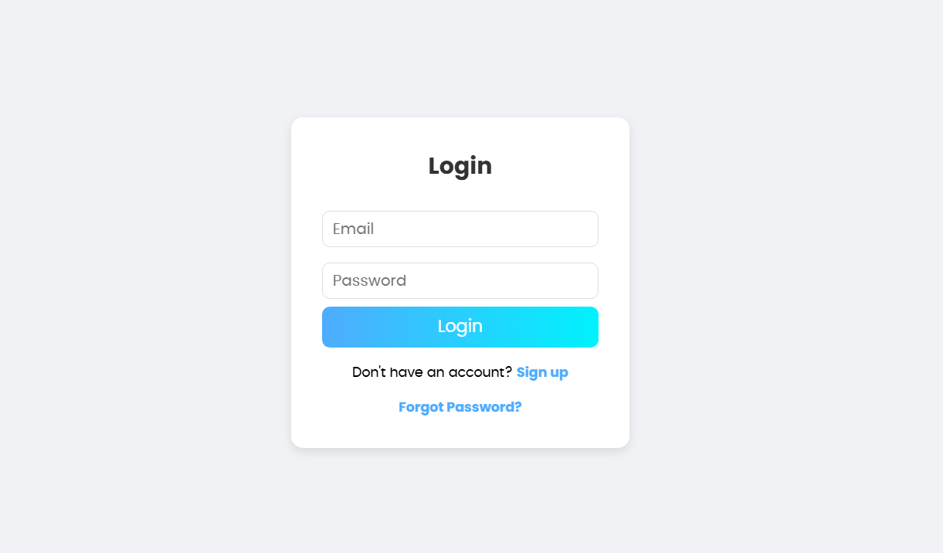**3. Forgot Password & OTP Verification**

* Users can reset their password by entering their registered email.
* An OTP is sent to the user's email for verification.
* Upon successful OTP verification, users can set a new password.

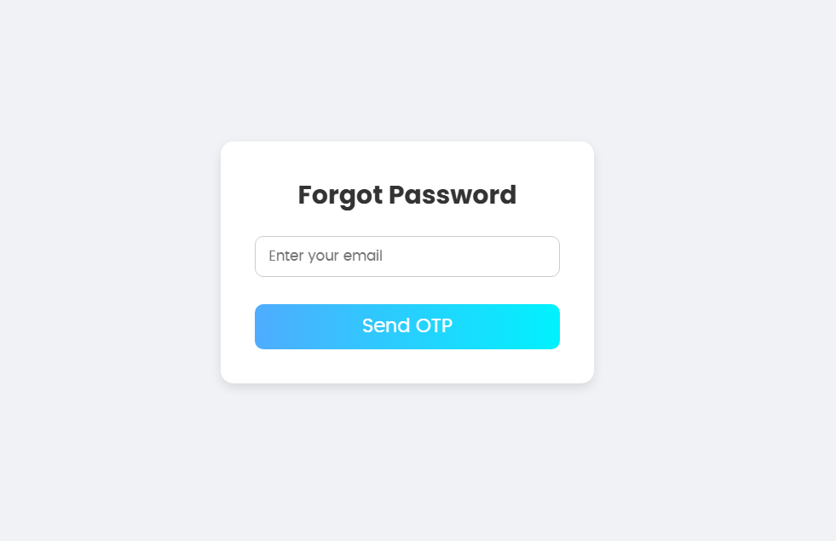

**Commands Used in CMD**

**1. Installing Angular CLI**

npm install -g @angular/cli

**2. Creating a New Angular Project**

ng new HubMarketocom

**3. Installing Required Dependencies**

npm install

**4. Running the Angular Application**

ng serve --open

**5. Installing Bootstrap (if used for UI styling)**

npm install bootstrap

**6. Installing Angular HttpClient for API Requests**

npm install @angular/common/http

**7. Installing Angular Router**

npm install @angular/router

**Folder Structure**

HubMarketocom/

│-- src/

│ ├-- app/

│ │ ├── components/

│ │ │ ├-- login/

│ │ │ ├-- signup/

│ │ │ ├-- forgot-password/

│ │ ├-- app-routing.module.ts

│ │ ├- app.module.ts

│ ├-- assets/

│ ├-- environments/

│ ├-- index.html

│ ├- styles.css

**API Endpoints Used**

* POST /signup → Registers a new user.
* POST /login → Logs in a user.
* POST /send-otp → Sends OTP to the registered email.
* POST /verify-otp → Verifies OTP.
* POST /reset-password → Resets the user’s password.

**Conclusion**

The frontend of HubMarketocom is successfully implemented using Angular, providing seamless authentication functionality. Further enhancements, such as UI improvements and error handling, can be added in future iterations.

